11.93: a) Taking torques about the left edge of the left leg, the bookcase would tip when 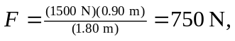 and would slip when 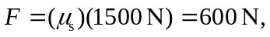 so the bookcase slides before tipping. b) If is vertical, there will be no net horizontal force and the bookcase could not slide. Again taking torques about the left edge of the left leg, the force necessary to tip the case is 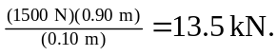 c) To slide, the friction force is 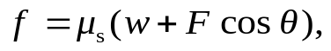 and setting this equal to 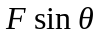 and solving for gives
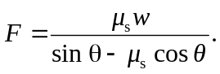
To tip, the condition is that the normal force exerted by the right leg is zero, and taking torques about the left edge of the left leg, and solving for gives
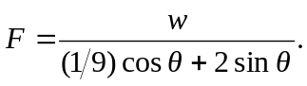
Setting the expression equal gives
and solving for gives
